**FRIO COUNTY COMMISSIONERS COURT MINUTES FOR**

**Meeting September 13, 2021**

On the 13th day of September, 2021, at 3:00 p.m., the Commissioners Court of Frio County met in a meeting with the following members either absent or present, to-wit: Arnulfo T. Luna, Frio County Judge was present; Joe Vela, Commissioner Pct 1 present; Richard Graf , Commissioner Pct 2 present; Raul Carrizales , Commissioner Pct 3 present; Jose Asuncion, Commissioner Pct 4 present; Joseph A. Sindon, Legal Counsel for Frio County Commissioners Court present; and Aaron Ibarra, Frio County Clerk present when the following meeting was held, to-wit:

I. Invocation and Pledge of Allegiance

II. Adopt Agenda

MOTION: RAUL CARRIZALES

SECOND: RICHARD GRAF

MOTION PASSED

III. Old Business

**PRESENTATION**

**ACTION AGENDA ITEMS**

1. Hon. Crystal Marquez, Frio County Auditor, requests:

Consider / take action on selecting an insurance provider from RFP’s received for insurance coverage for General Liability; Automobile Liability; Auto Physical Damage (Collision/Comprehensive); Crime; Cyber Liability; Property, to include: Buildings and Contents, Equipment Breakdown, Mobile Equipment, Electronic Data, Media and Hardware, that were received by the specified deadline

MOTION: RICHARD GRAF

SECOND: RAUL CARRIZALES

MOTION PASSED

(2) Tommy Navarro., Frio County Building Maintenance Supervisor, requests:- NO ACTION

2.1 Consider/take action on approving a Construction contract between in the amount of $1,459,415.68 between Frio County and Sandoval Contracting for the Building Improvements of the County Building located at 1796 BI 35E, Pearsall, Texas.

2.2 If the contract is approved, then approve and sign a resolution authorizing Frio County Judge Arnulfo C. Luna to execute the contract on behalf of Frio County, Texas.

IV. General Discussion

V. Citizens To Be Heard – REYNALDO TREVINO, CHRISTIAN WILSON, ROBERT HERRERA

*Please note that the Rules of Procedure, Conduct and Decorum at Meetings of the Commissioners Court of Frio County, Texas limit each speaker to a maximum of three (3) minutes to make his or her remarks. Inappropriate conduct or comments during this time, including but not limited to disruptive behavior, insults, personal attacks, and inappropriate language, may result in the speaker being ordered to leave the meeting and forfeit any remaining speaking time. For more information regarding the above-mentioned rules, please see the complete Rules of Procedure, Conduct and Decorum at Meetings of the Commissioners Court of Frio County, Texas, which is available upon request.*

VI. New Business

**PRESENTATION**

(1) Ronald Rocha, Attorney at Law, Linebarger Goggan Blair & Sampson, LLP**,** requests:

Update on the delinquent fines and collection services by Linebarger Goggan Blair &Sampson LLP.

(2) Dario V. Guerra III, P.E., Owner, Derby Ing., requests:

Presentation regarding the current status of Derby, Ing. And the private water system in the community of Derby, Texas.

MOTION: RAUL CARRIZALES

SECOND: RICHARD GRAF

MOTION PASSED

(3) Hon. Jose Asuncion, Frio County Commissioner, Precinct No. 4, requests:

Presentation from Alamo Area Council of Governments (AACOG) on the development of an economic and community Strategic Plan for Frio County, funded by a CARES Act grant from the Economic Development Administration.

**ACTION AGENDA ITEMS**

(1) Anna L. Alaniz, Frio County Tax Assessor-Collector, requests:

1.1 Conduct public hearing regarding proposed Tax Rate for the Frio County General Fund and the Frio County Lateral Road for the fiscal year beginning October 1, 2021 and ending September 30, 2022.

1.2 Consider/take action on approving the Frio County General Fund/Lateral Road tax rates for the fiscal year beginning October 1, 2021 and ending September 30, 2022.

1.3 If approved, sign an order levying taxes for the 2021-2022 fiscal year Frio County Tax Rate.

(2) Hon. Crystal Marquez, Frio County Auditor, requests:

2.1 Open and hold public hearing on the proposed Fiscal Year 2021-2022 budget.

(Pursuant to Texas Local Government Code, Section 111.007a)

2.2 Close public hearing. SESSIONED: 4:01PM – 4:29 PM

MOTION: RAUL CARRIZALES

SECOND: JOSE ASUNCION

MOTION PASSED

2.3 Consider/take action on making any necessary changes to the budget. (Pursuant to Texas Local Government Code, Section 111.008b)

2.4 Consider/take action on setting the salary, expenses and other allowances of elected county or precinct officers. (Pursuant to Texas Local Government Code, Section 152.013a)

MOTION: RAUL CARRIZALES

SECOND: JOSE ASUNCION

MOTION PASSED

2.5 Consider/take action on adopting Frio County Budget for Fiscal Year 2021-2022 by record vote. (Pursuant to Texas Local Government Code, Section 111.008a)

MOTION: JOSE ASUNCION

SECOND: RAUL CARRIZALES

MOTION PASSED

(3) Frio County Commissioners Court, requests:

Consider / take action to designate day of each month on which the court shall convene in a regular term in each month during the next fiscal year. (Pursuant to Texas Local Government Code, Section 81.005(a).

2ND MONDAY @ 3PM

MOTION: RAUL CARRIZALES

SECOND: RICHARD GRAF

MOTION PASSED

(4) Hon. Richard Graf, Frio County Commissioner, Precinct No. 2, requests:

Consider / take action on approving the completion of continuing education required by county commissioners online except for commissioners in the first 12-month period of the commissioner’s first term as pursuant to Texas Local Government Code § 81.0025.

MOTION: RICHARD GRAF

SECOND: JOSE ASUNCION

MOTION PASSED

(5) ~~Dan Wallace, CBEP~~, (LIN THOMPSON) Business Service Representative, Workforce Solutions Alamo, requests:

5.1 Consider/take action on approving Work Experience Worksite Agreement between Frio County and Workforce Solutions Alamo for a youth program in Frio County.

MOTION: JOSE ASUNCION

SECOND: RAUL CARRIZALES

MOTION PASSED

5.2 If the agreement is approved, then approve and sign a resolution authorizing Frio County Judge Arnulfo C. Luna to execute the contract on behalf of Frio County, Texas.

(6) Hon. Arnulfo C. Luna, Frio County Judge, requests:

6.1 Consider/take action on finding that circumstances present in all or part of the unincorporated areas of Frio County that create a public safety hazard that would be exacerbated by outdoor burning.

MOTION: RICHARD GRAF

SECOND: RAUL CARRIZALES

MOTION PASSED

6.2 Consider/take action on adopting an Order of the Frio County Commissioners Court Prohibiting or Restricting Outdoor Burning in the Unincorporated Areas of Frio County, Texas from September 16, 2021 to December 15, 2021.

(7) Hon. Arnulfo C. Luna, Frio County Judge, requests: NO ACTION

Consider/take action on approving donation of $10,000 - $15,000 to the Knights of Columbus Council 8327 for allocation for their community service program and repairs for the Knights Hall.

(8) Hon. Arnulfo C. Luna, Frio County Judge, requests: NO ACTION

Consider/take action on approving donation of $15,000 to the Claudio Gonzales VFW Post 9195 for allocation for their veteran service programs and repairs for the VFW Post Building and Veterans Cemetery.

(9) Hon. Aaron Ibarra, Frio County Clerk, requests:

9.1 Review Frio County Commissioners Court minutes for July 6, 7, 8, 12, 26 (x2), 27, 28, and 30, 2021.

9.2 Consider/Approve Frio County Commissioners Court minutes for July 6, 7, 8, 12, 26 (x2), 27, 28, and 30, 2021.

MOTION: RAUL CARRIZALES

SECOND: JOSE ASUNCION

MOTION PASSED

(10) Mary Perez, Frio County Human Resources Director, requests:

10.1 Consider/take action on approving Title Position Changes to the Frio County Pay Grade Scale.

MOTION: JOSE ASUNCION

SECOND: RAUL CARRIZALES

MOTION PASSED

10.2 Consider/take action on approving Frio County Employee Handbook Revisions along with the approved Frio County Sheriff's Pay Grade Scale and Frio County's Pay Grade Scale to be included in Handbook.

MOTION: RICHARD GRAF

SECOND: RAUL CARRIZALES

MOTION PASSED

(11) Hon. Crystal Marquez, Frio County Auditor, requests:

11.1 Consider / take action on approving three Security Light Agreements with Medina Electric to add scheduled lighting at the Hilltop Subdivision in Dilley, Texas, including the costs of $10.90 per month for each, and an additional one-time payment $599.24 for construction cost. Exact locations are as follows:

1. Corner of IH 35 FR & CR 4603/Barbra St. (additional construction cost)

2. Corner of IH 35 FR & CR 4601/Todd Rd.

1. Corner of IH 35 FR & CR 4600/Rusty Furnace Rd.

MOTION: JOSE ASUNCION

SECOND: RAUL CARRIZALES

MOTION PASSED

11.2 If the agreements are approved, consider/take action on approving resolution granting Frio County Judge Hon. Arnulfo C. Luna permission to execute the agreements on behalf of Frio County.

MOTION: JOSE ASUNCION

SECOND: RAUL CARRIZALES

MOTION PASSED

(12) Hon. Crystal Marquez, Frio County Auditor, requests:

12.1 Consider / take action to approve the budget amendments to the FISCAL YEAR 2020-2021 Frio County Budget, list below:

MOTION: RICHARD GRAF

SECOND: RAUL CARRIZALES

MOTION PASSED

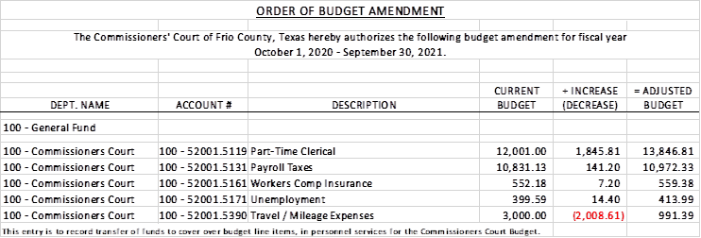

12.2 If the amendment is approved, consider/take action on signing order stating same.

MOTION: RICHARD GRAF

SECOND: RAUL CARRIZALES

MOTION PASSED

(13) Hon. Crystal Marquez, Frio County Auditor, requests:

13.1 Consider / take action to approve the budget amendments to the FISCAL YEAR 2020-2021 Frio County Budget, list below:

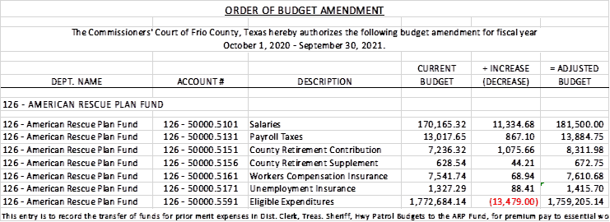

MOTION: RICHARD GRAF

SECOND: RAUL CARRIZALES

MOTION PASSED

13.2 If the amendment is approved, consider/take action on signing order stating same.

MOTION: RICHARD GRAF

SECOND: RAUL CARRIZALES

MOTION PASSED

(14) Hon. Crystal Marquez, Frio County Auditor, requests:

14.1 Consider / take action to approve the budget amendments to the FISCAL YEAR 2020-2021 Frio County Budget, list below:

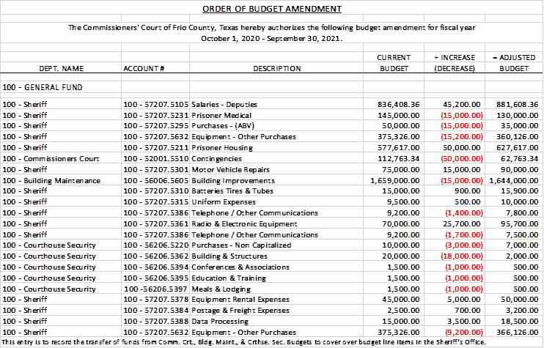

MOTION: RICHARD GRAF

SECOND: JOSE ASUNCION

MOTION PASSED

14.2 If the amendment is approved, consider/take action on signing order stating same.

MOTION: RICHARD GRAF

SECOND: JOSE ASUNCION

MOTION PASSED

(15) Hon. Jose Asuncion, Frio County Commissioner, Precinct No. 4, requests: NO ACTION

15.1 Discuss/take action on entering an interlocal agreement with Alamo Area Council of Governments (AACOG) for grant writing services to apply for the Outdoor Recreation and Tourism Funding Opportunity through the Economic Development Administration

15.2 If the agreement is approved, then approve and sign a resolution authorizing Frio County Judge Arnulfo C. Luna to execute the contract on behalf of Frio County, Texas.

(16) Hon. Jose Asuncion, Frio County Commissioner, Precinct No. 4, requests:

16.1 Consider/take action on rescinding vote approving a Memorandum of Understanding between Frio County and the Dilley Independent School District for collection of property taxes by the Frio County Trax Assessor/Collector that was executed on July 26, 2021.

MOTION: JOSE ASUNCION

SECOND: RAUL CARRIZALES

MOTION PASSED

16.2 Consider/take action on entering into a Memorandum of Understanding between Frio County and the Dilley Independent School District for collection of property taxes by the Frio County Tax Assessor/Collector.

MOTION: JOSE ASUNCION

SECOND: RAUL CARRIZALES

MOTION PASSED

16.3 If the Memorandum of Understanding is approved, consider take action om approving a resolution authorizing Frio County Judge Arnulfo C. Luna to execute the MOU on behalf of Frio County.

(17) Tommy Navarro., Frio County Building Maintenance Supervisor, requests: NO ACTION

17.1 Consider/take action on opening sealed bids received by the specific deadline for the Roof Building Improvements of the County buildings located below in Pearsall, Tx.

1) Building 400, 404 and 410 S. Pecan

2) Building 411 E. Brazes St

17.2 Consider/take action on selecting a winning bid from the bids received.

(18) Hon. Arnulfo C. Luna, Frio County Judge, requests:

Consider and act on waiving the Frio Fireman's Park rental fee at the request of Esmeralda Cano for September 19, 2021.  BBQ Plate sale will be held to assist in medical expenses for

a COVID patient.  If approved then refund rental payment made.

MOTION: RICHARD GRAF

SECOND: RAUL CARRIZLES

MOTION PASSED

(19) Hon. Arnulfo C. Luna, Frio County Judge, requests:

19.1 Consider/take action on removing the Frio County Engineer, Roxana Garcia, effective October 15, 2021 and send notice to Roxana Garcia regarding same.

19.2 If removal of the Frio County Engineer is approved, discussion regarding the Frio County Engineers position, the position of the Frio County Road and Bridge Administrator, and the possibility of hiring an engineering firm to provide engineering services to Frio County on an as needed basis.

(20) Hon. Arnulfo C. Luna, Frio County Judge, requests:

20.1 Consider/take action on participating in the Global Opiate Settlement and approve the Settlement Participation Forms and the Texas Term Sheet.

MOTION: RAUL CARRIZALES

SECOND: RICHARD GRAF

MOTION PASSED

20.2 If Frio County’s participation is approved, consider take action om approving a resolution authorizing Frio County Judge Arnulfo C. Luna to execute the required documents on behalf of Frio County.

MOTION: RAUL CARRIZALES

SECOND: RICHARD GRAF

MOTION PASSED

(21) Roxana Garcia, P.E., Frio County Engineer, requests: NO ACTION

Discussion regarding the Drainage Study at CR 3314 at San Miguel Creek.

(22) Roxana Garcia, P.E., Frio County Engineer, requests: NO ACTION

22.1 Consider/take action on accepting and enacting the Third Amended Frio County Conference Room Rules and Regulations.

22.2 If the above rules are approved, consider/take action on signing a order enacting said rules.

(23) Roxana Garcia, P.E., Frio County Engineer, requests:

23.1 Consider/take action on approving and adopting resolutions granting permits to US Energy Development Corp. to lay bore, construct and maintain one (1) 4” pipeline operated at 50 PSI on County Road 4757/Leona River Road right-of-way for a total permit fee of $500.00.

MOTION: RICHARD GRAF

SECOND: JOSE ASUNCION

MOTION PASSED

23.2 If the resolution is approved and adopted, then authorize Frio County Judge Arnulfo C. Luna to execute the permit on behalf of Frio County, Texas to US Energy Development Corp.

MOTION: RICHARD GRAF

SECOND: JOSE ASUNCION

MOTION PASSED

(24) Roxana Garcia, P.E., Frio County Engineer, requests:

24.1 Consider/take action on approving a utility permit to Valley Telephone Cooperative, Inc. VTX1 Companies for placing of a fiber optic cable under the replacement bridge on CR 2500/Sadler Road at San Miguel Creek for a waived fee as the line is having to be replaced due to county bridge replacement.

MOTION: RICHARD GRAF

SECOND: RAUL CARRIZALES

MOTION PASSED

24.2 If the permit is approved and adopted, then authorize Frio County Judge Arnulfo C. Luna to execute the permit on behalf of Frio County, Texas to US Energy Development Corp.

MOTION: RICHARD GRAF

SECOND: RAUL CARRIZALES

MOTION PASSED

(25) Roxana Garcia, P.E., Frio County Engineer, requests: NO ACTION

25.1 Consider / take action on approving Supplemental Work Authorization 1 to Work Authorization No. 1 between Frio County and Gessner Engineering, LLC.

25.2 If the work authorization is approved, consider / take action on approving and signing resolution authorizing Hon. Judge Arnulfo Luna to enter into same on behalf of Frio County.

(26) Roxana Garcia, P.E., Frio County Engineer, requests:

Discussion regarding the progress of the Dilley Annex and WIC Building Improvement Projects.

(27) Hon. Arnulfo C. Luna, Frio County Judge, requests:

Consider/take action on approving Frio County Vaccine Incentive Program Guidelines.

MOTION: JOSE ASUNCION

SECOND: RAUL CARRIZALES

MOTION PASSED

AMMEND PROGRAM WILL BEGIN SEPT. 14

(28) Frio County Commissioners Court, requests:

Receive in person from the following county officials the following reports as mandated by law:

28.1 Presentation by Frio County Treasurer of detailed report as mandated by Section 114.026, Local Government (“Code”) (this report is to be presented at each **regular term of commissioners court).**

28.2 Frio County Treasurer to exhibit the books and accounts of that office for the inspection of the commissioners court (**to be done at each regular term of commissioners court).**

28.3 Consider/take action on authorizing the execution by Frio County Commissioners Court (the Judge and each commissioner) of an affidavit stating the requirements of the treasurer’s report have been met as mandated by section 114.026 of the Code.

28.4 Consider/take action on execution of an order of the commissioners court approving the county treasurer’s report and order their publication in the Frio-Nueces Current as mandated by Section 114.026 of the Code or publication on the county’s website.

(29) Frio County Commissioners Court requests:

Presentation, pursuant to Section 114.044 of the Local Government Code, by:

1. Frio County District Clerk;

2. Frio County Clerk

3. Frio County Treasurer

4. Frio County Attorney

5. Frio County Judge

6. Frio County Sheriff

7. Frio County Auditor

8. Frio County Justice of the Peace

9. Frio County Constables

**(who collects or handles any money for the use of the county) of all fines imposed, judgments rendered and collected, and all jury fees collected by the respected courts in favor of or for the use of the county and at that time when the reports are presented to present receipts vouchers that show disposition of the money, fines or judgments.**

After examination by the commissioners court as to the correctness of the reports, consider/action on directing the county clerk to enter information in county finance records as mandated by Section 114.044 of the Code.

MOTION: RICHARD GRAF

SECOND: RAUL CARRIZALES

MOTION PASSED

(30) Documents (resolutions, orders, contracts, etc.) to be signed.

(31) Allow bills payable

MOTION: RAUL CARRIZALES

SECOND: JOSE ASUNCION

MOTION PASSED

(32) Adjourn

MOTION: RAUL CARRIZALES

SECOND: RICHARD GRAF

MOTION PASSED